No. | Incident Photo | Damage Description
1. | 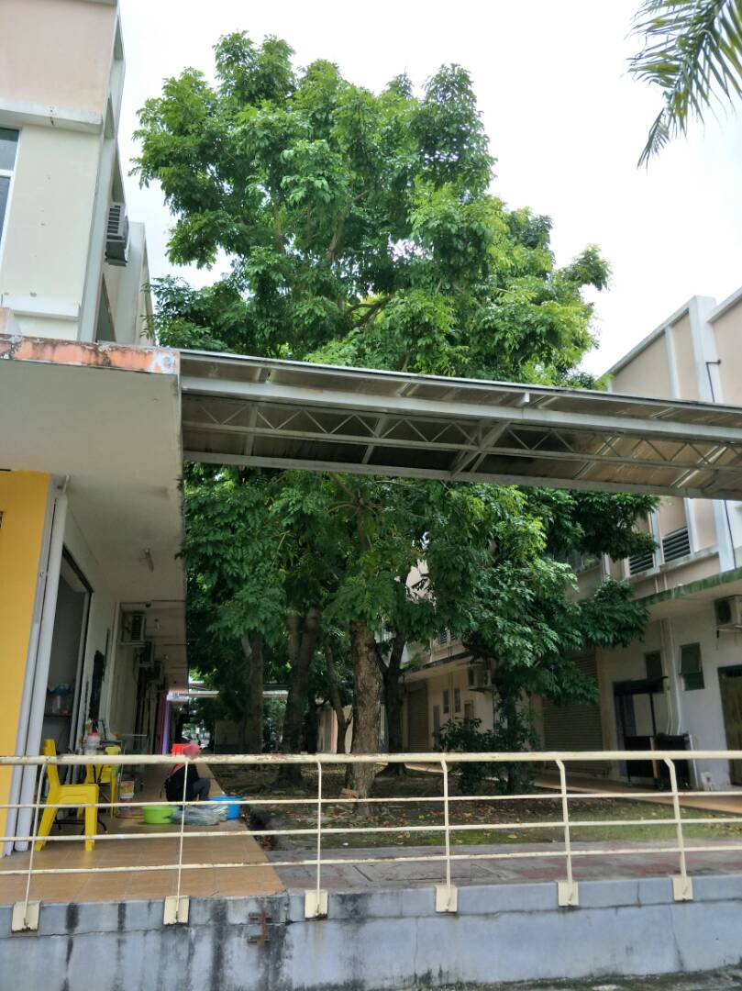 | Location : Lot 41, behind Restoran  Kedai Makan Taiwan  (Depan Restoran Ikan  Bakar)
2. | 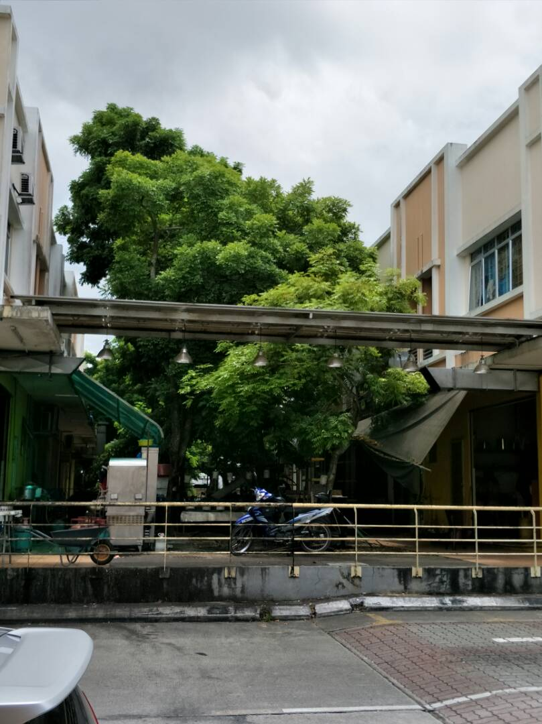 | Location : Lot 5, behind Restoran Resepi Melayu Padang

No. | Incident Photo | Damage Description
3. | 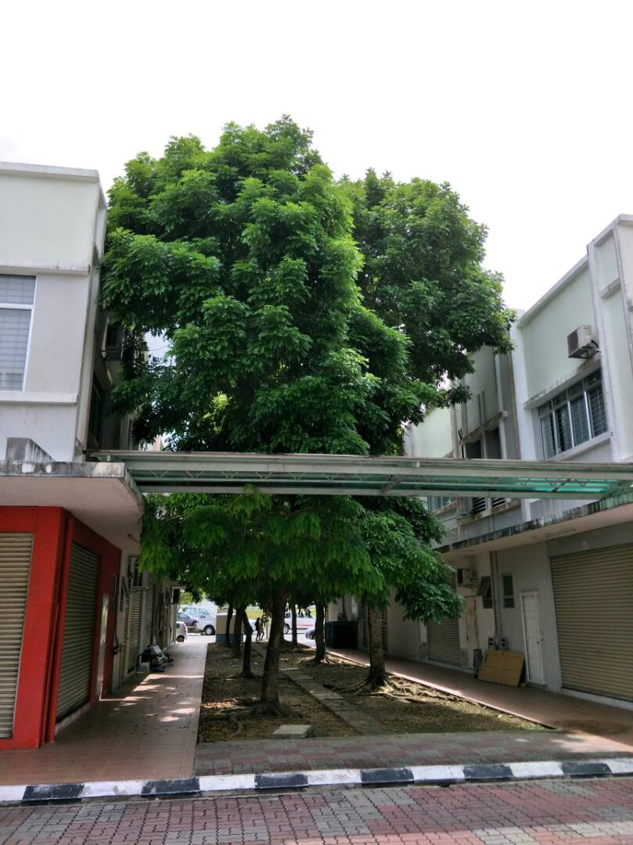 | Location : Lot 15, Behind Travel Inter Phoenix (Sebaris CIMB Bank)
4. | 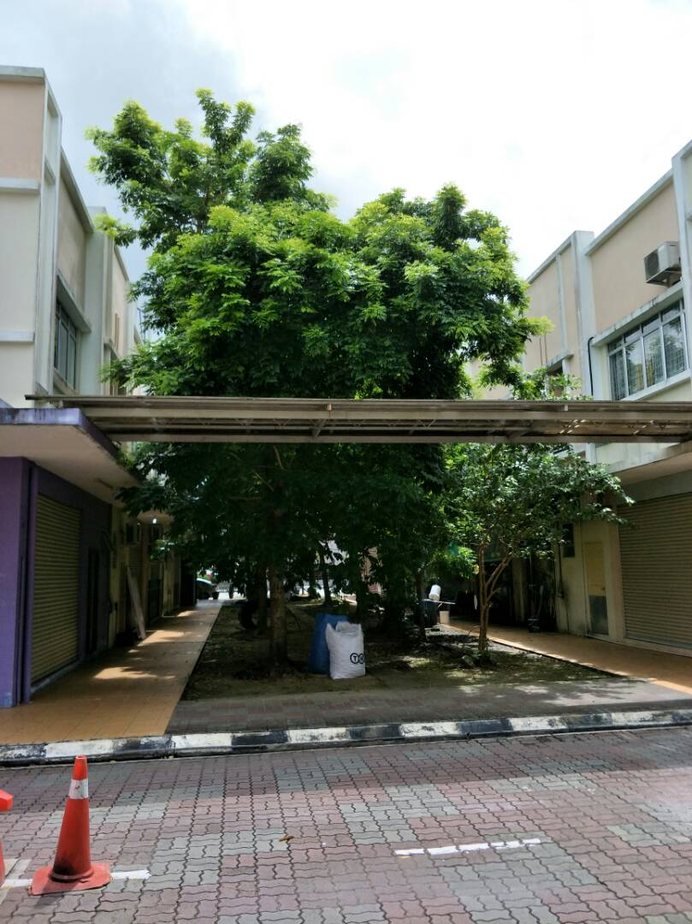 | Location : Lot 35, behind KK Lim & Co

No. | Incident Photo | Damage Description
5. | 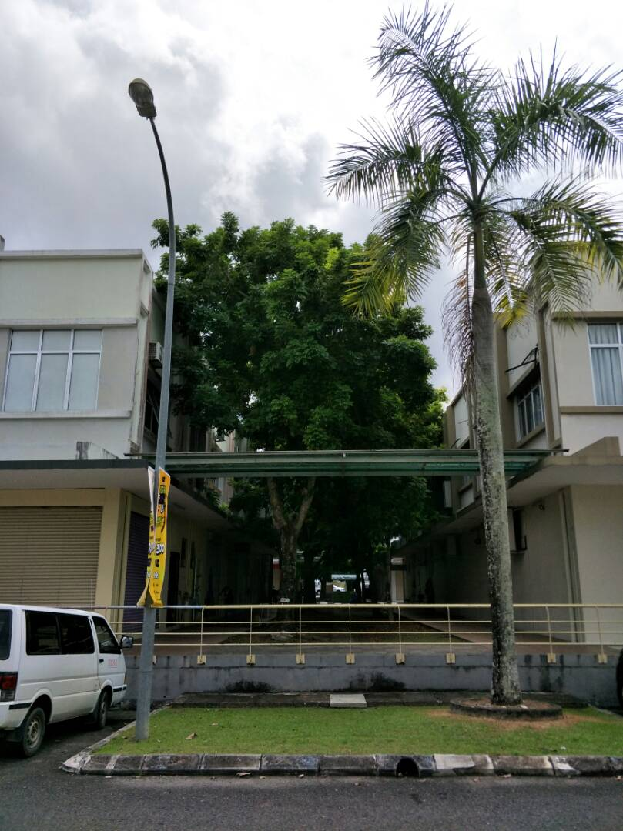 | Location : Lot 16-20, Behind Utama Medical centre
6. | 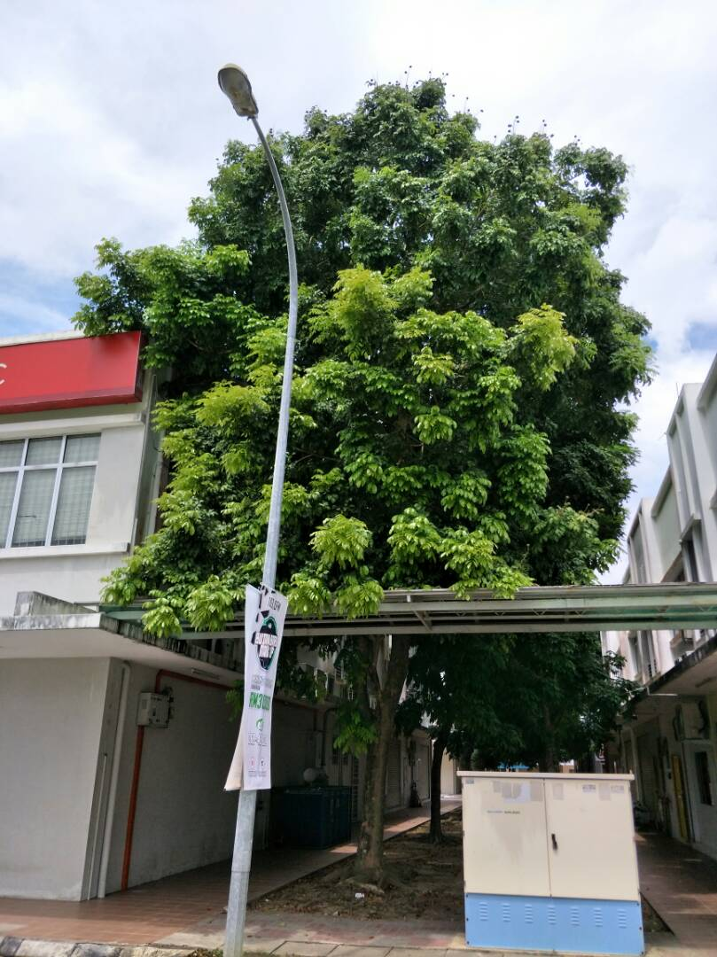 | Location : Lot 100, Behind CIMB Bank

No. | Incident Photo | Damage Description
7. | 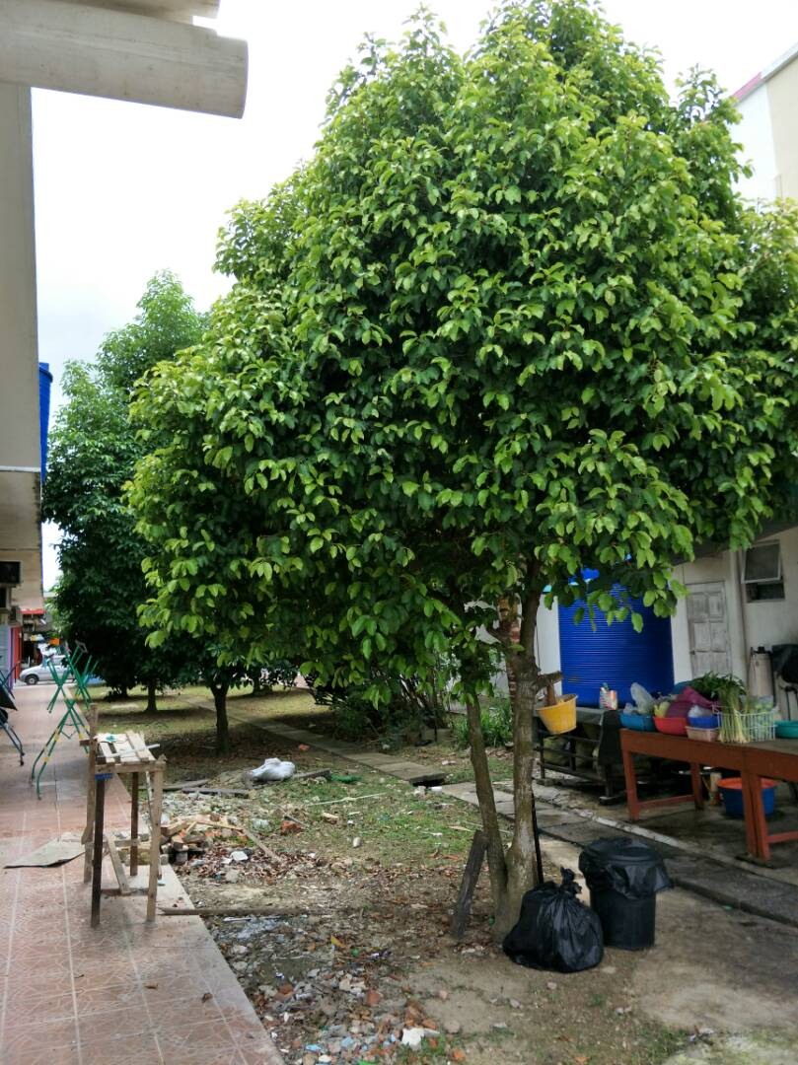 | Location : Lot 60, Restoran Ikan Bakar Sederhana
8. | 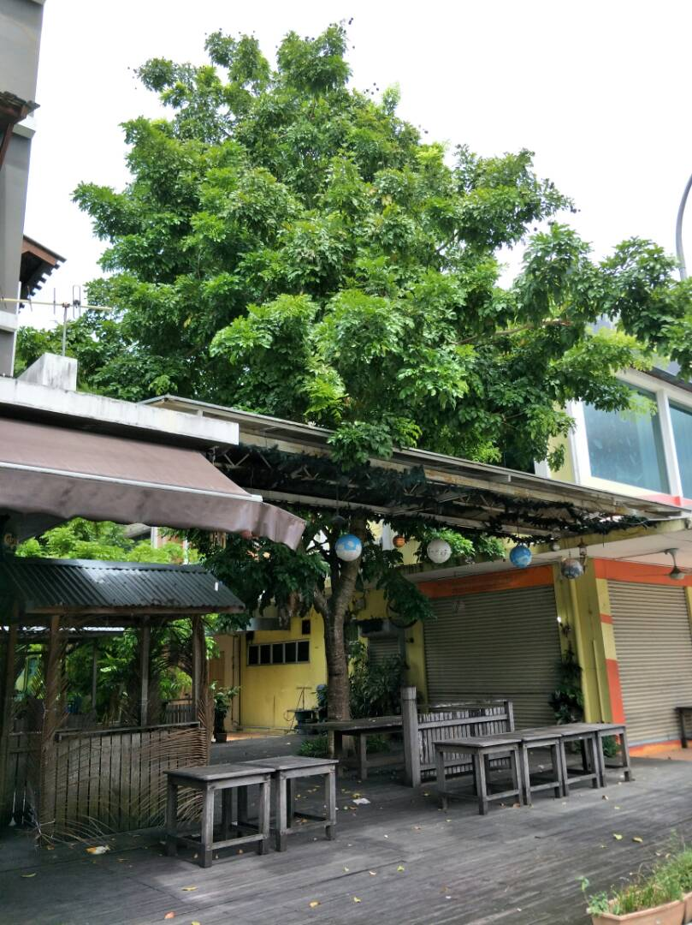 | Location : Lot 10, Restoran Old City

